**Requirement Document for Store Management System**

**Project summary**

This project is about creating a Store Management website for online buying of stationary items. It shows the customer a catalogue of various things available for purchase in the store. A shopping cart is supplied to the user to assist online purchases. The consumer may add the thing they want to buy to their shopping cart and then check out. The user may also score and submit reviews / comments on the things purchased from this website. This website also allows users to create a login ID and user profile to keep their information, delivery address, and Wishlist. This Store Management System is made up of five parts.

**Project scope**

Project will start once main work on store management system is finished.

First and foremost, the team will analyze activities and prepare the bare minimum of project management documentation: estimates, a list of risks, and a milestone chart (list) from which we will be able to agree on the project's ultimate scope and dates. First and foremost, the team will analyze activities and prepare the bare minimum of project management documentation: estimates, a list of risks, and a milestone chart (list) from which we will be able to agree on the project's ultimate scope and dates.

**Purpose**

The Benefits and purpose of the Stores Management System is

* It is used as an intranet and Internet Application.
* Providing High-Security.
* Easy Business Solutions.

**Goals:** Accuracy, performance, scalability.

The primary goal of the Stores Management System is to automate all operations associated with the usage of stores, such as maintenance and operation work, capital works, and so on.

This automation will nearly completely remove the requirement for clerical workers in the store's technical and accounting sectors.

**Project deliverables**

This project will provide users with the ability to login and add things to their basket as they see fit, as well as a high-security payment gateway with credit, debit, and no-cost EMI capabilities, as well as cash on delivery and an invoice.

**When will project will delivered**

The project will be provided once the developer team has completed the development phase and the testing team has completed the testing phase in accordance with the limitations, and the project will be delivered as a result of successful development and testing.

**Assumptions**

For all difficulties, a workaround is available to execute with a fair amount of time and risk. Otherwise, all we can do is file a bug report and wait for a patch from our developer team.

**Constraints**

* The application should be made available on time.
* There is a minor probability that QA effort on other products will impact the timetable of the store management system.
* Additional requests for updates to the shop management application may have an impact on the SMA timetable.

**Users**

Here in this project application user can find three different logins admin, user, guest.

**Responsibilities**

The responsibilities of the 'Stores Management System package' are to automate almost all of the processes mentioned above in order to reduce clerical labour of the staff working in Stores both technical and as well as Accounts departments by using the software Industry's latest technologies and cost effective tools, thereby providing better control to management by avoiding manual errors, etc.

**Functional Requirements**

Store Management System allows user to access these features

• Login (Admin, User, Guest)

• Admin: Admin is the one who is going to add all the products and their details

• User: user going to add all the specified details about himself to avail the offers.

• Guest: guest user is all about to do only buying, he doesn’t get any privileges to use offers

• Categories-In store management system, we have few categories those are

1) Vegetables

2) Chocolates

3) Cookies

4) Groceries

5) Beauty products

6) Pet supplies

• Search- In search box user allowed to search the products.

• Wishlist: When user wanted to save the liked items, those items going add in user wishlist by clicking add to wishlist option.

• Cart-When user wanted to place an order then those item going to add in cart

• Orders: user can find his previous orders and current orders here.

• Menu Bar-

1) Home- when clicking this button, then you will go to home page

2) My Account –Information about user, user can add or modify data

3) Offers- Offers will displayed in the offers section

4) Customer Service- If user faces any problem, user can contact the customer service.

5) Rate and Review Products- user can give rating and reviews to the products.

6) FAQ- user can find frequently asked questions.

**Non-Functional Requirements**

Scalability: This application will perform well under an increased or expanding workload or scope.

**Flow Diagram**

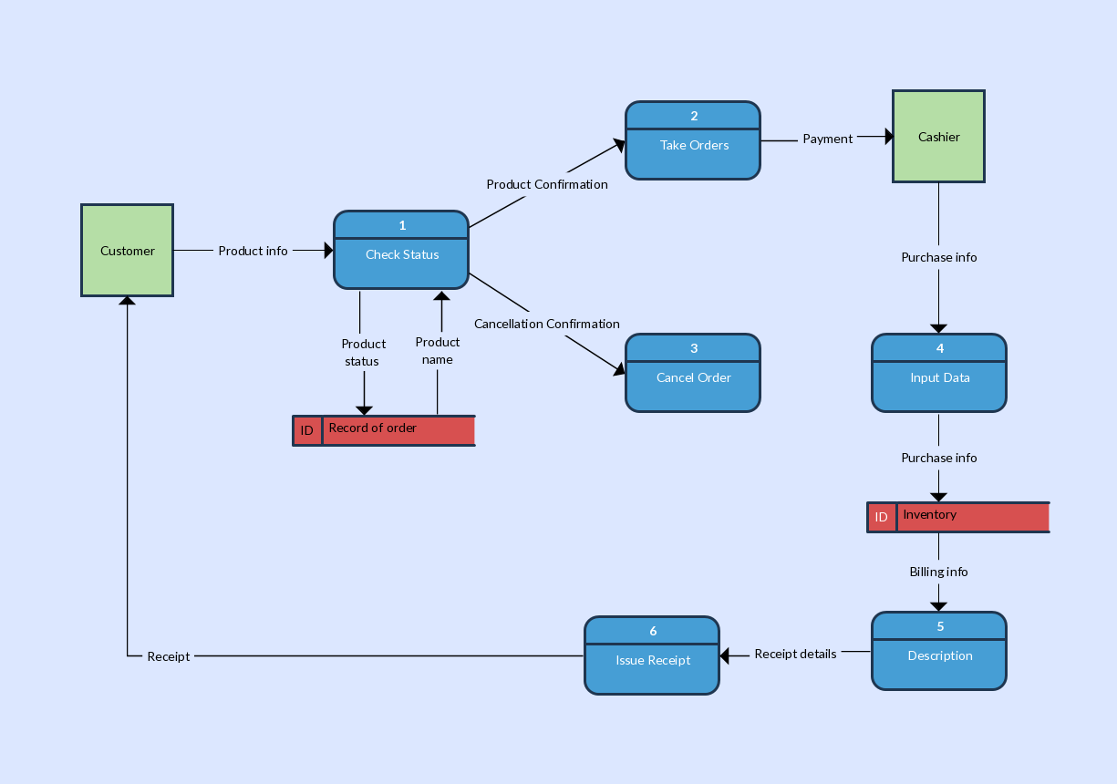

**Database Tables**

